K2 / BAOWE empowering women through entrepreneurship
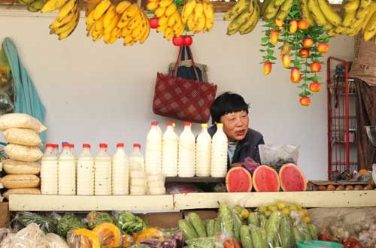

BAOWE empowering women through entrepreneurship
April 30, 2017 K2 Leave a comment 555 Views
For Phub Lham, life became difficult when she separated from her husband. With four children to look after and without any qualification, the 58-year-old woman came to Thimphu looking for a job. She started selling doma on Thimphu streets when she was 29.
“I first bought doma with Nu 60. That’s how I started my small business,” she said, smiling. “I brought up all my kids selling doma in Thimphu.”
All her children are now settled except for the youngest.
It is common sight in Thimphu to see rural women from all parts of the country selling agricultural produce and goods, including snacks and fast foods on the streets.
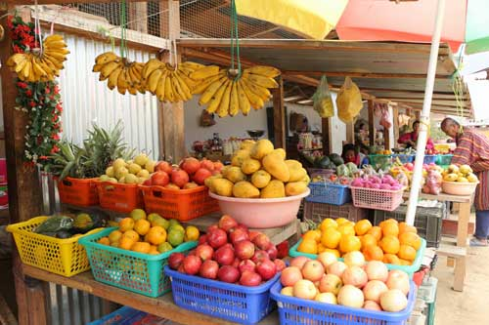BAOWE constructed the fruit and vegetable stalls for street vendors in Hejo
The number of street hawkers in the city increased as there are many women like Phub Lham who have become a street vendors to sustain their livelihoods.
The Thimphu Thromde inspectors, who monitor the street hawkers, confiscate the goods and fine them whenever they encounter with hawkers on the streets, but that didn’t stop women like Phub Lham to stop selling snacks and fast food because they do not have any other means to make a living.
The street hawkers in the city played cat and mouse game with the thromde inspectors until the Bhutan Association of Women Entrepreneurs (BAOWE) came up with a project called Women-owned Open Market (WOOM) to help street hawkers like Phub Lham.
BAOWE is a non-government organisation, registered under the CSO Act 2007 of Bhutan, facilitates, empowers and promotes women’s knowledge and skills for business.
BAOWE endeavours to create a vibrant business environment for women, involving a broad partnership of actors, enablers, contributors and innovators to open opportunities for women and men with a special focus on the poor, disadvantaged, disabled and marginalised.
The secretariat is organised along four broad programmes to begin with which will be altered as BAOWE grows. They are development of women-run and women owned cluster cooperatives; micro finance programme; research, branding, packaging and marketing of women’s products; promotion of women’s niche enterprises and addressing urban poverty.
WOOM project is mainly implemented to empowering the economically disadvantage in urban centres.
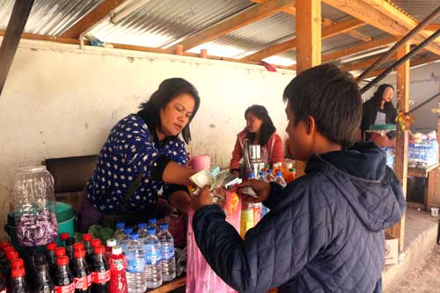A BAOWE beneficiary runs a fast food stall in the JDWNRH area
Today, there are about 110 members in the country who benefit from the BAOWE’s WOOM project. Each one of them has been provided dignified space to sell their own special niche goods.
There are 64 capable and potential women beneficiaries in the sales outlet in Hejo, Jungshina, hospital area and bus booking area in Thimphu.
Phub Lham said that with the establishment of the sales outlet, street hawkers like her don’t have to sit in the sun or rain to sell goods. “I am happy that we don’t have to bear the harassment of the thromde inspectors nor run when we see them.”
Sustainable Rural Biomass Energy (SRBE) and Advancing Economic Opportunity for Women and Children in rural areas of Zhemgang are some of the other projects of BAOWE, besides WOOM.
Some 30 gewogs in Zhemgang, Tsirang and Dagana benefitted from the SRBE project. A total of 75 village technicians were recruited and trained in construction of improved stove, construction of about 430 stoves has been completed in Zhemgang. In Tsirang and Dagana, the activity is still ongoing.
The project aims for energy efficiency, resulting in household members spending lesser time in piling the required quantity of firewood, which in turn will give them more time to engage in economic activities, thereby improving their livelihood and positive impact on health due to less emission of smoke.
The project – Advancing Economic Opportunity for Women and Children – in rural areas of Zhemgang, aims to bring positive changes in the livelihood practices of women and girls through promotion of groups. Some 18 self-help groups (SHGs) were formed in Zhamgang.
With the implementation of this project, 315 rural households of Zhemgang were benefited.
BAOWE has also set up small food processing unit at Jungshina in Thimphu for those who wish to dry their edible products such as meat, fish, cheese and all sorts of vegetables with minimal affordable charges.
The unit is eco-friendly and clean. It was set up for the convenience and welfare of the community.
RORUM is a credit cooperative that encourages its members to save and enables them to obtain loans, which they may require for various purposes from their accumulated savings.
BAOWE initiated RORUM to develop and promote savings habit among the low-income groups and those who are denied access to financial services from Bhutan’s mainstream financial institutions.
Nearly 70 people like Phub Lham in Thimphu have joined the cooperative. People without collaterals and bank accounts today have their own personal savings accounts with RORUM where they save it on a weekly basis.
Every Monday, one of the staffs goes for their savings collection throughout Thimphu where all the members save between Nu 100 to Nu 1,000 weekly.
A vegetable vendor at the Hejo sales outlet, Kinley Bidha, 57, said that the initiative helps her save some money for her future. “Even if I save Nu 100 a month, I would at least have some money saved during the crises time,” she said. “And I feel financially secure that I have some savings.”
The members are also allowed to apply for a loan to revive their alternative businesses if their small businesses fail or if they want to expand their micro businesses.
Only an active member of the cooperative can avail of the RORUM services.
The founder and CEO of BAOWE, Damchae Dem, said that there is nothing a woman can’t do is she puts her mind to it. “With access to information, education and a conducive working environment a woman has true potential and can become productive member of society capable of leadership roles. Empowerment of women needs to begin with her participation in different spheres of life.”
BAOWE
Mission
BAOWE will work to develop a social-consciousness-driven private sector, promote women entrepreneurs at the grassroots and SME level thereby contributing to poverty reduction, self-reliance, and business from a GNH perspective to achieve economic empowerment of women.
BAOWE’s objectives
CEO of BAOWE, Damchae Dem founded the CSO with the aim of reaching out to marginalized sectors of society mainly single mothers, unorganised sector and unemployed youth.
In Bhutan, BAOWE represents:
SAARC Chamber Women Entrepreneurs Council (www.scwec.com)
South Asian Women Development Forum (www.sawdf.org)
LDC-Watch (www.ldcwatch.org)
To further the aims and objectives of the organisation, BAOWE will also engage in following types of activities:
To borrow or raise funds required for the purpose of the Association on such terms and conditions as may be determined.
To invest the unutilized funds of the Association in investments, securities or property as may be determined.
To support any charitable organisation or purpose that would further meet the social objectives of the Association and its members;
To encourage and facilitate social activities, which will promote understanding and goodwill among all stakeholders, like-minded organisations in Bhutan and beyond. To promote friendly relations and pursue active collaboration with relevant organisations in Bhutan and abroad.
With support from Helvetas Swiss Intercooperation and Bhutan Centre for Media and Democracy (BCMD)
Dechen Tshomo

